# Title: On all pages. Unlogical multiple placement of an unlickable word “Показати” on the “footer” of a website.

**Priority:** Medium

**Severity:** S4 Minor

**Environment:**Browser Mozilla Firefox 118.0.1 (64-bit)

Browser Chromium 117.0.5938.132

**Steps to reproduce**

1. Open the Main page: <https://oxford-med.com.ua/ua/>

2. Scroll down to the gray “footer” with a list of contact information

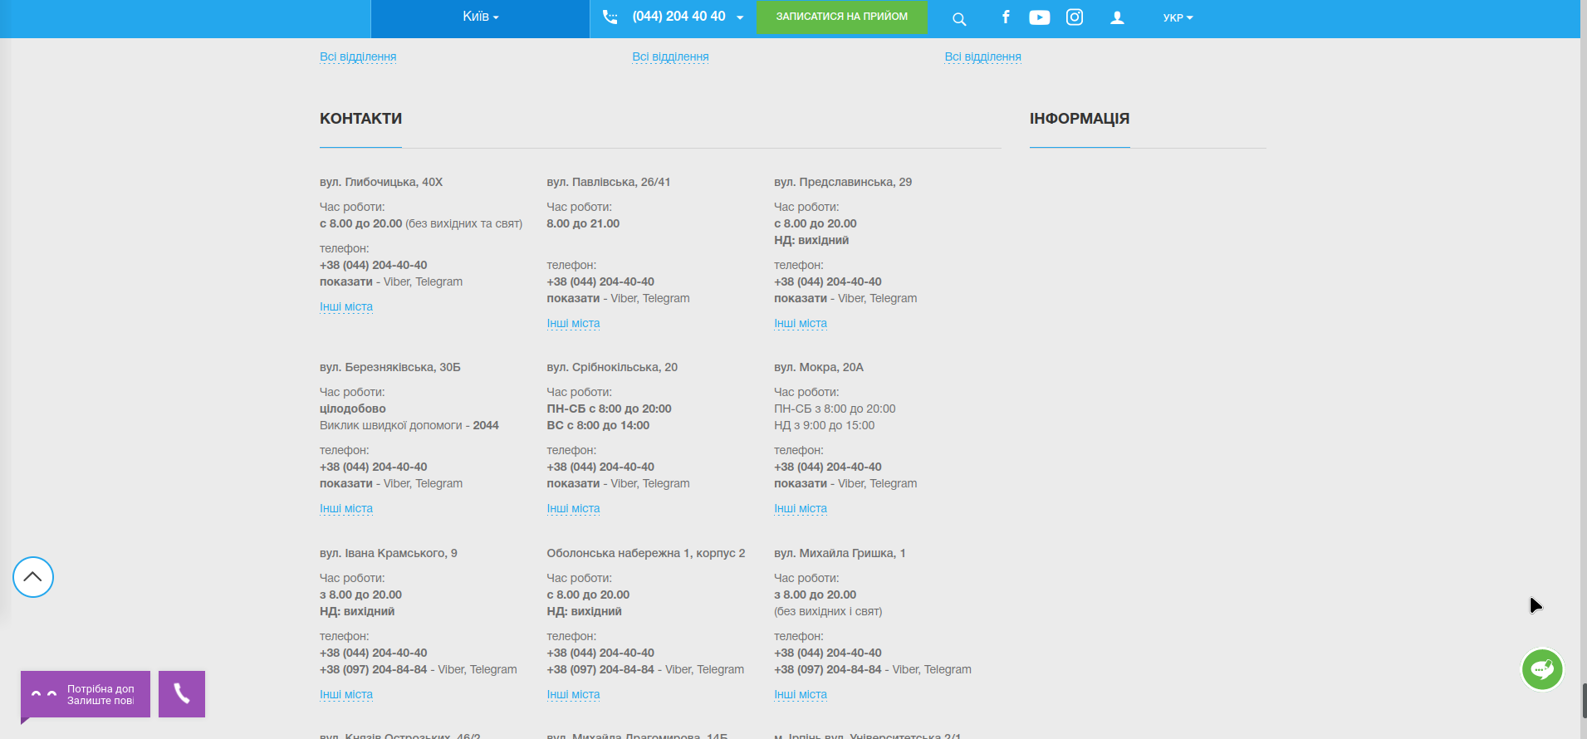

3. Click on “показати” in a “вул. Глибочицька, 40X“ section

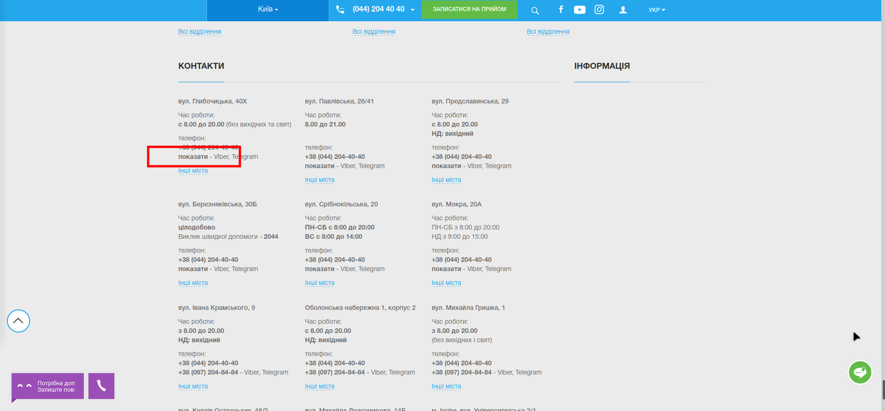

**Actual result**

Nothing happened. The word “показати” is unclickable, while a phone number is already displayed. So, it is difficult to understand the reason of placing this word.

**Expected result**

According to UI-UX, all sections, blocks, and texts must have logic placement. So, the word “показати” or must be deleted, or a telephone must be hided (and clicking on the word “показати” must reveal this phone).

*Screenshot from* ***Jira****:*

